vom AUGENSTEIN KENNEL Announces
Emma von Julson X Don II vom Kiefernwalde
PUPPIES JANUARY OF 2026
For further details, questions and pricing information feel free to contact either or both:
Amanda Augenstein: Cell: 724-470-5167
Email: Amandaaug@yahoo.com
Jim Julson: Cell: 605-530-0074
Email: JAMESLJULSON@outlook.com

ONE MALE AVAILABLE!!
Born 1/13/2026

We are excited to announce a joint cooperative venture between vom Augenstein Kennel and von Julson Kennel to produce and support the litter and the owners of the offspring from the Emma (Eva) von Julson X Don II vom Kiefernwalde mating. The pups will be whelped by and registered un the vom Augenstein Kennel, Amanda Augenstein, owner. Jim Julson, Julson Kennel, is the breeder and owner of the Eva. Eva was trained and mated in Germany. Jim actively selected the male and over saw the mating of Eva while he was in Germany, Oct and Nov 2025. Jim will walk along beside Amanda by taking an active and supporting roles in the whelping and care of the mother and her litter and the support of owners. Owners can depend on both Amanda and Jim to be involved in the selection of owners and the support of pup owners as the pups become members of their new homes. Training resources are provided with each pup that schedule and provide instruction for each training step from the time the pup arrives home at 8 weeks of age until it is 6 months old. They will also provide help and guidance during the owners training post 6 months, of age, and the preparation and registration for JGHV testing, coat and physical confirmation evaluation as well as hip and ureter image collection and evaluation.
Additional information on these 2 KlM, their background and what are Amanda and Jim expectations from the owners is explained below.
Pricing information details and schedule is available upon request.
BACKGROUND: If biology is consistent pups would be born mid-January 2026 and could go to their new homes in March. Emma comes from a long line of Tecklenburger Land KlM. Tecklenburger Land, breeder Erwin Wallman, is one of the oldest and most respected KlM breeders in Germany. Erwin got his first KlM, as a teenager, in 1965 from Edmund Lons (Loens), who is credited with promoting and establishing the KlM breed. Only because of unique special circumstances was I able to acquire Emma’s mother (Elsa III Tecklenburger Land). Erwin has been mother line breeding to refine his line for over 40 years. Emma comes from 45 years of this line breeding. I WILL INTRODUCE YOU TO EMMA FIRST AND DON II WILL FOLLOW BELOW EMMA.
EMMA von JULSON: Emma was born April 6, 2024. To give you an idea of her temperament, trainability, stability and intelligence I am going to list how she performed in her JGHV field performance tests competed before she was 2 years old.
Emma’s Statistics:
VDH/KlM#: 24-0357
Brown & White, Whelped: 06/04/2024, 51cm Hips
Hips (HD-A, HQ 0.99)
Ureter (A)
Form/Coat Rating: G/SG
JGHV TESTING, FIELD EVALUATIONS:
VJP 69 (11 months old)
HZP 184, LE 10 (15 months old)
VGP 328 Prize II, overnight blood track (18 months old)
Sight/Scent laut (LN means she is laut in the area of hoofed game)
Test Evaluation Sheets are available upon request.
EMMA (Eva) SHORT STORY:
Eva’s mother is Elsa III (Emmy) von Tecklenburger Land. Elsa III is the result of 40+ years of motherline breeding. That mother line continued with the litter that produced Emma. Only because of unique special circumstances was I able to acquire Emmy. KlM of this quality, who are fully trained and approved for breeding do not come up for sale very often and especially to buyers out of Germany. I personally know of only 3.
Eva was produced using Erik vom Gussein who is a produce of this same motherline. He is the result of a litter from one of those 3 females imported into the USA I referenced in the paragraph above.
I kept three females from Emmy’s litter to improve my chances of having a female I could use for breeding to continue this line. I placed two of those females, in Germany at 15 weeks of age, with KlM trainer contacts of mine and I kept and trained one. Eva is one of the pups trained in Germany.
OVERVIEW OF THE LITTER EVA IS A MEMBER OF:
The litter was 10 puppies in size, 6 females and 3 males. All 10 of the puppies in this litter were evaluated through the JGHV breed qualifying field performance evaluations (VJP & HZP).
STATISTICS:
Field Performance Evaluations:
VJP (Spring Natural Ability Puppy Test) average score 72
HZP (Fall Breed Test, advanced Natural Ability Test) 7 successfully completed. The 3 that did not pass failed to retrieve and deliver the rabbit or the duck due to incomplete trained retrieve training.
VGP (Utility Test, measures the finished versatile dog, 26 subjects, over 2 days, across field, forest, water, obedience. The dog must possess a balanced temperament, a lot of natural ability, and a high level of trainability to pass this test ) 3 ran and 3 passed, all under 19 months old. Eva was one of those 3.

Here is a link to an explanation of and the reasoning for these performance test:
German Hunting Dog Testing: The Jagdgebrauchshundverband ( JGHV). All German versatile hunting dog breeds that are registered with their German parent breed club participate in exactly the same evaluation tests. Link to explanation and reason for the JGHV tests: https://share.google/cTm6KaS7i7LvjsMfy
Health, Coat and Physical Confirmation Evaluations:
Seven of the 10 pups in the litter had their hips x-rayed and ureter evaluated by color doppler.
HIP QUALITY: 7 - “A”
EURETER QUALITY: 7 – “A”
BREED SHOW: 8 where evaluated. 6 were rated “GOOD” or higher and 2 were disqualified because their tail was noticeably too short.
As I write this story, (Nov. 3, 2025) I am in Germany staying with KlM Breeder friends and colleagues, Heiko and Tanja Jurgen. I have had Eva in my possession for just a few days. Her trainer educated me on the German commands and body language he trained her with. After working with her for only 2 days I hunted her on her first German Driven Hunt and my 3rd Driven Hunt. There were a total of 19 hunters and 14 versatile hunting dogs. She performed surprisingly well and was clued into me as her handler. In fact the morning of the hunt I was standing in front of her kennel and Tanja looked at us and said, “she is already looking at you like, you are my boss, what should I do.” I had worked with her the first 15 weeks of her life before I took her to Germany and that had probably helped.
I am telling you all this to emphasize the quality, temperament, cooperation, retrieving and trainability of this line and the generally uniformity in the line and pretty much across this whole litter. I would expect the same in Eva’s litter. But breeding is always a crap shoot and you just never know. We just try to do the best we can!! 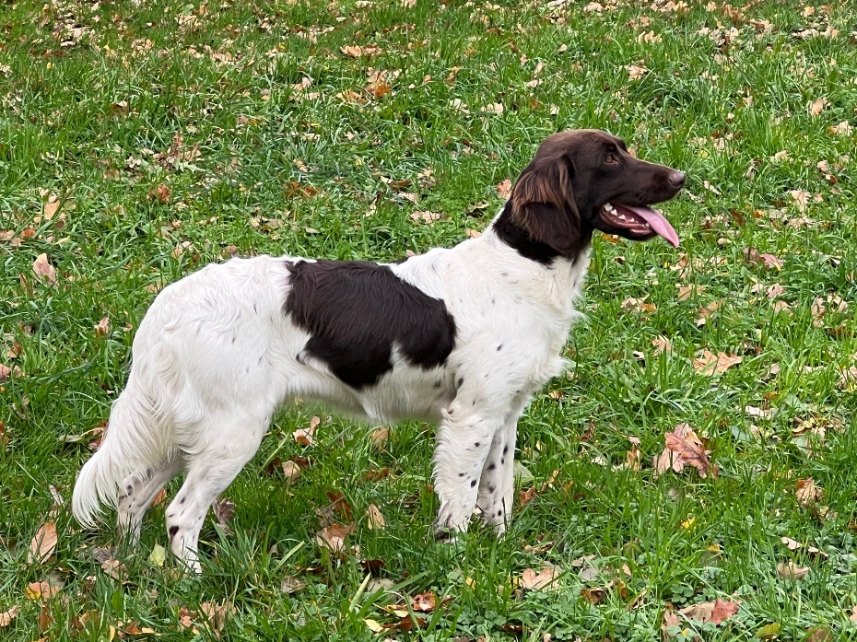

With the valuable input from Erwin Wallmann, Tecklenburger Land, we have selected the following male for this mating.
DON II vom KEIFERNWALDE:
VDH# 20-0096, Whelped: 01/20/2020, 56 cm Hips
HD-A, HQ 1.01
Ureter (A)
Form/Coat Rating: SG/SG

JGHV TESTING AND FIELD EVALUATIONS:
VJP 70
HZP 167 pts LE 11
Scent laut
VGP 336 Prize I, overnight blood track
Btr (description below)
HN (Description below)
Test Evaluation Sheets are available upon request.
Description of Btr Award: Bringtreueprüfung (Btr)

Retrieving Reliability Test: During the Btr the dog demonstrates that it is a reliable retriever by finding, picking up and delivering to its handler any cold, dead game that was found accidentally, without any influence by the handler. This test is conducted in a forested area during the months of August through April. At least two hours before the test a cold, dead fox will be carried on a circuitous route to a designated place in the forest. Once the dog is released with a SEARCH command, the handler must remain completely silent. The dog passes the test if it finds and retrieves the fox to its handler within 20 minutes of being released.

Description of HN Award: Härtenachweis: (HN)
The Toughness Certificate: Is awarded when a dog demonstrates that it is fearless and able when confronted with furred predators or feral game during a hunting situation. An independent witness must observe this occurrence and provide documentation of the event to the Group Breed Warden

DON SHORT STORY:
While I was in Germany, I visited several males Erwin Walmann had suggested for consideration as a mate to Eva. I made the 2.5-hour trip to meet Don, his family and see him work in the water and field. This gave me an idea of his temperament, trainability, stability, drive, focus, cooperation and intelligence. Please review his performance in the JGHV Field performance tests. These are very respectable performance tests. The important thing to realize is this is the owner’s first hunting dog. It is the first dog he has actively trained. For a first time owner, handler, trainer, hunter and his dog to accomplish what this team did is a testament to Don’s trainability, cooperation and drive. If I understand what the owner told me, he did very little trained retrieve training on the table. Since it was during COVID the whole family had a lot of time to work with Don and accomplish the retrieving training by working with him on retrieving beginning at a very young age. This also tells me Don has a lot of natural retrieving instinct and desire. I need to verify this retrieving information using a native German speaking hunter so I am sure of its accuracy.
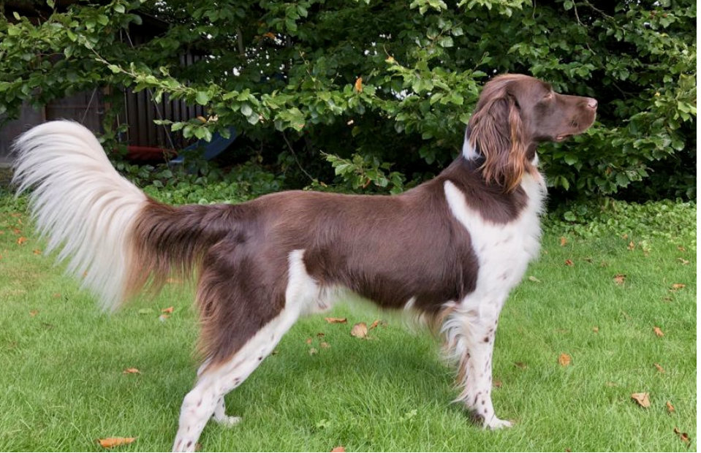

WHAT WE EXPECT FROM THE OWNERS
It is only through the spirit of cooperation and shared responsibility between the breeder and the owner that continued improvements to the breed can be made.
We expect owners to prepare and test their pups through the JGHV, VJP (Spring Natural Ability Test) and HZP (Fall Utility Test) and evaluate the hips and ureter. (Description and value of these evaluations explained here: German Hunting Dog Testing: The Jagdgebrauchshundverband ( JGHV). All German versatile hunting dog breeds that are registered with their German parent breed club participate in exactly the same evaluation tests.
Link to explanation and reason for the JGHV tests: https://share.google/cTm6KaS7i7LvjsMfy)
As the owner, preparing and testing your pup, you acquire a better trained hunting companion as well as improving your dog’s hunting ability. This testing provides an invaluable base of knowledge from which we can evaluate and improve our breeding program and the breed as a whole. It is only through the spirit of cooperation and shared responsibility between the breeder and the owner that continued improvements to the breed can be made. In order to have a good versatile hunting dog, you can be proud of, this training preparation necessary to successfully complete the field evaluation tests is something you should be doing even if you did not test. Evaluation of the physical structure, coat, hips and ureter provide valuable information about the dog’s long-term functionality and capacity to stand up to the rigors of hunting in various terrain, habitat and water. Without the proper physical structure and coat the peak performance longevity of the dog can be greatly limited.
We sell only to hunters who have the interest, understanding and desire to meet our expectations. Those types of owners will reap the benefits by being able to continue to acquire exceptional stable hunting companions that are also good family members. At the same time, they will contribute to future generations of hunters by enabling those future generations to experience the same adventure and joy a field, with a truly acceptable stable hunting partner and companion, that those past generations did!!

