Elsa III vom Tecklenburger Land x Ulrik vom Teichhof
PUPPIES expected late 2026 or early 2027
For further details, questions or pricing information feel free to contact
Jim Julson Cell: 605-530-0074
Email: JAMESLJULSON@OUTLOOK.COM

We are planning to mate Elsa III vom Tecklenburgerland (Emmy) to Ulrik vom Teichhof. I am not exactly sure when Emmy will come into season. But she will be in Germany starting the end of May and be there until she is confirmed pregnant. I was very fortunate to acquire Emmy. She comes from one of the oldest and most respected KlM kennels in Germany. The breeder got his first KlM, as a teenager, in 1965 from Hermann Lons (Loens), who is credited with promoting and establishing the KlM breed. I have known her breeder for a number of years. Only because of unique special circumstances was I able to acquire her. KlM of this quality, who was fully trained and approved for breeding do not come up for sale very often and especially to buyers outside of Germany. I personally only know of 3. The breeder has been mother line breeding to refine his line for over 40 years. Emmy is a product of his dedicated work. It shows. For a better understanding of what Emmy can produce have a look at the attachment titled: Elsa III Tecklenburger Land 2024 litter, Comparing VJP results of all 2024 litters.
I WILL INTRODUCE YOU TO EMMY FIRST AND ULRIK FOLLOW BELOW EMMY.
Emmy was born, May 23, 2021. To give you an idea of her temperament, trainability, stability and intelligence I am going to list how she performed in her JGHV field performance tests competed before she was 2 years old.
Elsa III Tecklenburger Land
Emmy’s Statistics:
VDH/KlM#: 21-0887
Hellschimmel, Whelped: 05/23/2021, 53 cm
Hips: HD-A, HQ 0.96
Ureter (A)
Form/Coat Rating: V/SG

JGHV Testing & Awards:
VJP 75 (10 months old)
HZP 186, LE 10 (15.5 months old)
VGP 335 Prize I (16.5 months old)
Sight/scent laut
Btr Award (9.5 months old) before JVP test. Description below
AH Award (10 months old) During her VJP. Description Below
HN Award. Description Below

Test Evaluation Sheets are available upon request.

ELSA JGHV PERFORMANCE AWARD DESCRIPTIONS:
Btr COMPLETED 3/6/2022 She was 9 1/2 months. This was before she competed the VJP.
Description of Btr Award: Bringtreueprüfung (Btr):Retrieving Reliability Test: During the Btr the dog demonstrates that it is a reliable retriever by finding, picking up and delivering to its handler any cold, dead game that was found accidentally, without any influence by the handler. This test is conducted in a forested area during the months of August through April. At least two hours before the test a cold, dead fox will be carried on a circuitous route to a designated place in the forest. Once the dog is released with a SEARCH command, the handler must remain completely silent. The dog passes the test if it finds and retrieves the fox to its handler within 20 minutes of being released.

VJP (75) & AH Award COMPLETED 3/30/222 She was 10+ months old. At her VJP evaluation she received the AH award.

Description of AH Award: Armbruster Halt Award: The Armbruster Halt Award is granted when a dog demonstrates the ability to be obedient on the track of a hare during the VJP, HZP or VGP. The dog is whistled to the DOWN position when it sights a hare. After the hare is out of sight, the dog is released to track it and must demonstrate at least a GOOD track. The dog must demonstrate obedience on every hare it has seen during the test and must be 20 m from its handler at least once.

Description of HN Award: Härtenachweis (HN): The Toughness Certificate is awarded when a dog demonstrates that it is fearless and able when confronted with furred predators or feral game during a hunting situation. An independent witness must observe this occurrence and provide documentation of the event to the Group Breed Warden.

Elsa III (Emmy) SHORT STORY::

Emmy’s first litter in 2024 was one of the top litters produced that year within the KlM Association, Germany and the USA combined. To view the details of how this was determined click on this link: https://www.julsonkennel.com/produced-2024-top-litter
I traveled to Germany to pick Emmy up Mid February of 2023. The owner was on vacation. He emailed me the commands he used when training her before I arrived in Germany and Heiko helped me overcome my American accent and pronounce the German commands correctly…so I sounded like a German, at least when using those commands.

The Breeder clued me in by telling me, “This is a dog that you will not stop and casually talk to your neighbor.” He left it at that. I know him well enough I knew exactly what he was telling me. By the time I had worked with her the first time there was no question his description was correct! She is very focused on the task in the field.

YOU CAN VIEW EMMY IN THE VIDEOS UNDER THE TABS:
Our Breeding Program
What is a Kleine Munsterlander
Who We Are
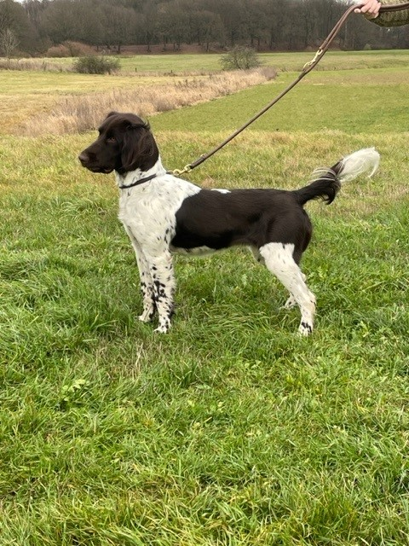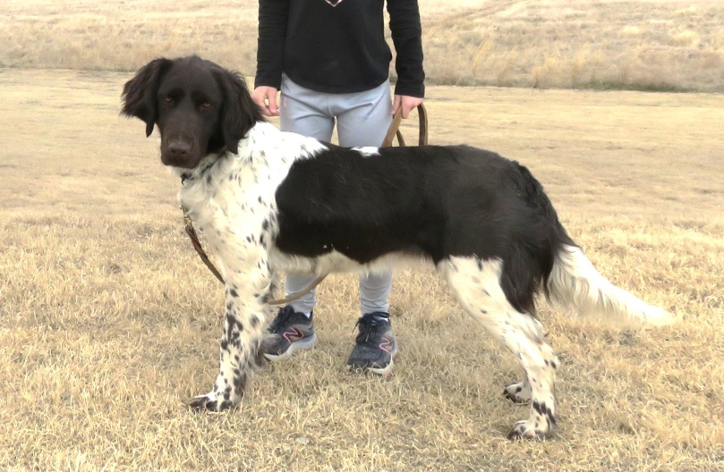

OVERVIEW OF Emmy’s Litter, 2024:
The litter was 10 puppies in size, 6 females and 3 males. All 10 of the puppies in this litter were evaluated through the JGHV breed qualifying field performance evaluations (VJP & HZP).
STATISTICS:
Field Performance Evaluations:
VJP (Spring Natural Ability Puppy Test) All 10 completed with an average score of 72.
HZP (Fall Breed Test, advanced Natural Ability Test) 7 successfully completed. The 3 that did not pass failed to retrieve and deliver the rabbit or the duck due to incomplete trained retrieve training.
VGP (Utility Test) 3 successfully completed by the time they were 18 months old. The test measures the finished versatile dog, 26 subjects, over 2 days, across field, forest, water, obedience. The dog must possess a balanced temperament, a lot of natural ability, and a high level of trainability to pass this test ) 3 ran and 3 passed, all under 19 months old. Eva was one of those 3.

Here is a link to an explanation of and the reasoning for these performance test:
German Hunting Dog Testing: The Jagdgebrauchshundverband ( JGHV). All German versatile hunting dog breeds that are registered with their German parent breed club participate in exactly the same evaluation tests. Link to explanation and reason for the JGHV tests: https://share.google/cTm6KaS7i7LvjsMfy
Health, Coat and Physical Confirmation Evaluations:
Seven of the 10 pups in the litter had their hips x-rayed and ureter evaluated by color doppler.
HIP QUALITY: 7 - “A”
EURETER QUALITY: 7 – “A”
BREED SHOW: 8 where evaluated. 6 were rated “GOOD” or higher and 2 were disqualified because their tail was noticeably too short.

With the valuable input from Elsa III breeder, we have selected the following male for this mating
Ulrik vom Teichhof
Ulrik’s Statistics:
VDH# 20-1192
Brown-white, Whelped: 12/27/2020, 56 cm
Hips: HD-A, HQ 0.97
Ureter (A)
Form/Coat Rating: SG/V
JGHV Tests:
VJP 66
HZP 188
VGP 306 PZ II
Scent & Sight Laut

Test Evaluation Sheets are available upon request.

I spent parts of several days with Ulrik and his owner. Both in the field and around their farmyard. I also oversaw the mating of Ulrik to Erika von Julson (a pup from Emmy’s 2024 litter) the fall of 2025. I was in Germany at that time running Erika in the Lonssuche and hunting.

He is a very cooperative dog who was produced by a long established KlM kennel in Germany. The owner’s (Kalli) first hunting dog was a KlM that was already trained. Ulrik is his second KlM and he trained Ulrik himself with the guidance of Wencke Seifert.

Kalli the owner had never run or even seen a VJP, HZP or VGP run before. What I am about to write is hilarious, yet almost unbelievable but true. I got the same description from Kalli and one of the judges who judged this team in all 3 of these field evaluation tests. It also provides some evidence that Ulrik is “genetically trained.” Knowing the kennel Ulrik comes from that does not surprise me.

Kali never used an e-collar while training him and even for the first 3 years that he hunted Ulrik. Finally in 2025, when I was there taking Erika von Julson to mate with Ulrik an e-collar supplier asked me to deliver an e-collar to Kalli. Ulrik was becoming a bit more independent as he matured.

So, this almost unbelievable store goes. The team (Kalli and Ulrik) completed the VJP and the HZP. The judges told him he should run the Bundes HZP. The team qualified to do this because Ulrik did such a great job during their HZP. During the Bundes HZP this team did such an impressive job the judges told him he should run his dog through a VGP. The VGP is demanding 2 days versatile hunting dog field evaluation and the standard for versatility! No other test comes close to verifying the versatile hunting ability of a dog as does the VGP. Kalli and judge verified to me that every step of the VGP they had to explain to Kalli what he and the dog were supposed to do. They had never really practiced ahead of time. They learned what they had to do as they completed each category of the VGP test. It was obvious Kalli and Ulrik had developed a good relationship and understanding while training for the HZP. I am shaking my head in disbelief as Kalli is explaining it to me. He even went to the extent of telling and showing me his approach during the test. The judges told him what the team was supposed to do. Kalli would look at Ulrik and say a few things to explain to him and they did it! I am laughing and saying no way and the one of the judges at that test said, “That is not too far off!” NO wink and NO nod from the judge. the judge was serious!!! But after I actual witnessed them in the field I could believe what they told me. To me the terms that explain it, and I had picked up reading Robert Wehle book, Snakefoot: The Making of a Champion was, “genetically trained.”

This team successfully competed the VJP, HZP and VGP (overnight blood track) in the same year!
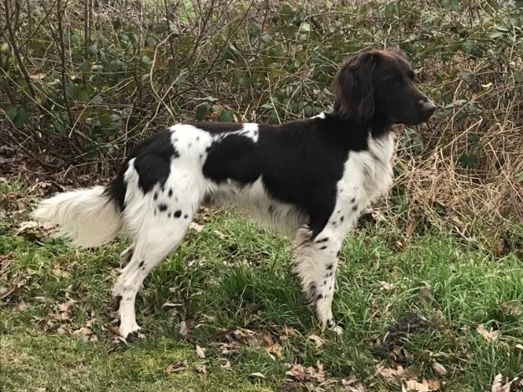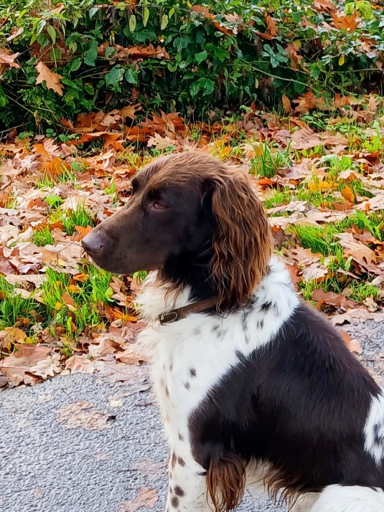

WHAT WE EXPECT FROM THE OWNERS OF THIS LITTER
It is only through the spirit of cooperation and shared responsibility between the breeder and the owner that continued improvements to the breed can be made.
We expect owners to prepare and test their pups through the JGHV, VJP (Spring Natural Ability Test) and HZP (Fall Utility Test) and evaluate the hips and ureter. (Description and value of these evaluations explained here: German Hunting Dog Testing: The Jagdgebrauchshundverband ( JGHV). All German versatile hunting dog breeds that are registered with their German parent breed club participate in exactly the same evaluation tests.
Link to explanation and reason for the JGHV tests: https://share.google/cTm6KaS7i7LvjsMfy)
As the owner, preparing and testing your pup, you acquire a better trained hunting companion as well as improving your dog’s hunting ability. This testing provides an invaluable base of knowledge from which we can evaluate and improve our breeding program and the breed as a whole. It is only through the spirit of cooperation and shared responsibility between the breeder and the owner that continued improvements to the breed can be made. In order to have a good versatile hunting dog, you can be proud of, this training preparation necessary to successfully complete the field evaluation tests is something you should be doing even if you did not test. Evaluation of the physical structure, coat, hips and ureter provide valuable information about the dog’s long-term functionality and capacity to stand up to the rigors of hunting in various terrain, habitat and water. Without the proper physical structure and coat the peak performance longevity of the dog can be greatly limited.
We sell only to hunters who have the interest, understanding and desire to meet our expectations. Those types of owners will reap the benefits by being able to continue to acquire exceptional stable hunting companions that are also good family members. At the same time, they will contribute to future generations of hunters by enabling those future generations to experience the same adventure and joy a field, with a truly acceptable stable hunting partner and companion, that those past generations did!!

